Creating A Photoshop Button  
By Rebecca Russell

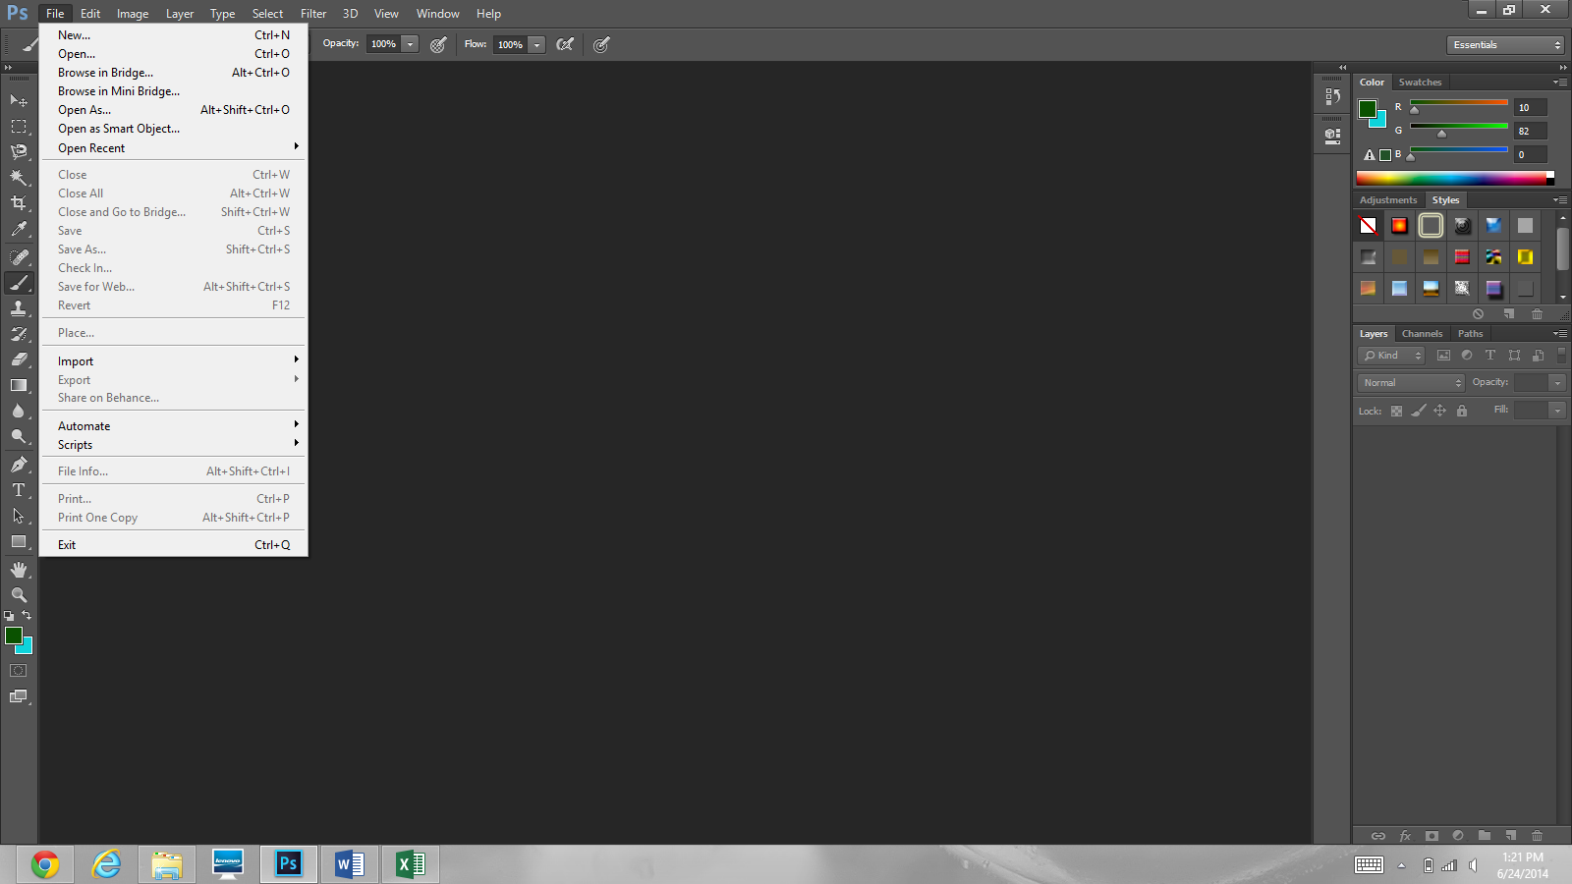

Roll over the tab “File” then click “New…” from the drop down menu that appears. This will launch a dialogue box to set the parameters for the new Photoshop file.

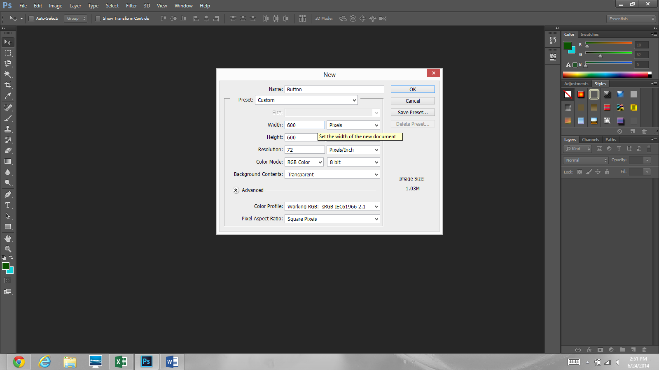

For the purposes of this tutorial I will name the new file “Button” and pick the preset “Default Photoshop Size.” This will set the parameters of the file for me. The only things I will change from this preset is the “Background Contents” and “Size.” I have set the size of the file to be 600px by 600px. The default in this preset for background contents is White. However, by choosing a transparent background, I can insert this button into my app without a white box around the button.

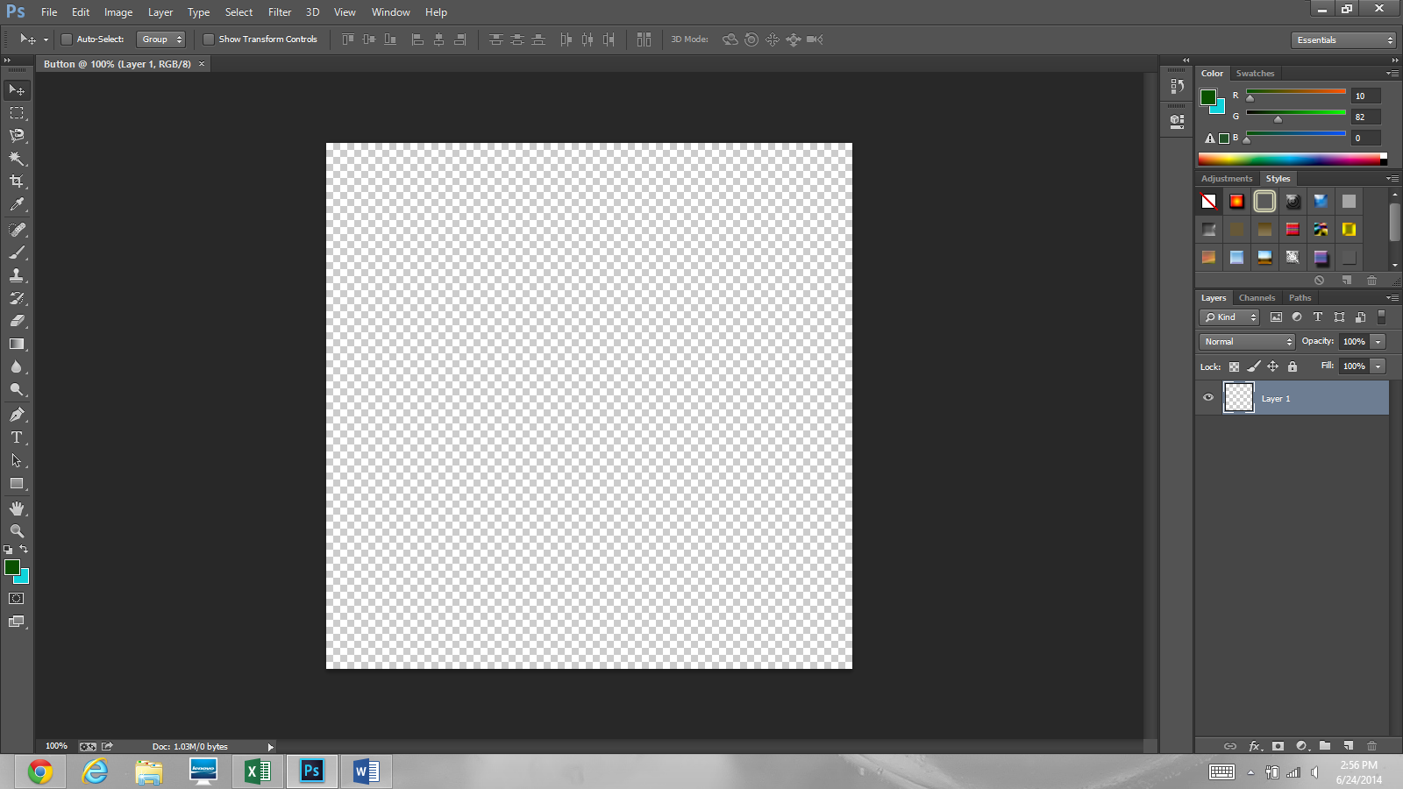

This is the new Photoshop file. The background is checked to show us that the background is transparent.

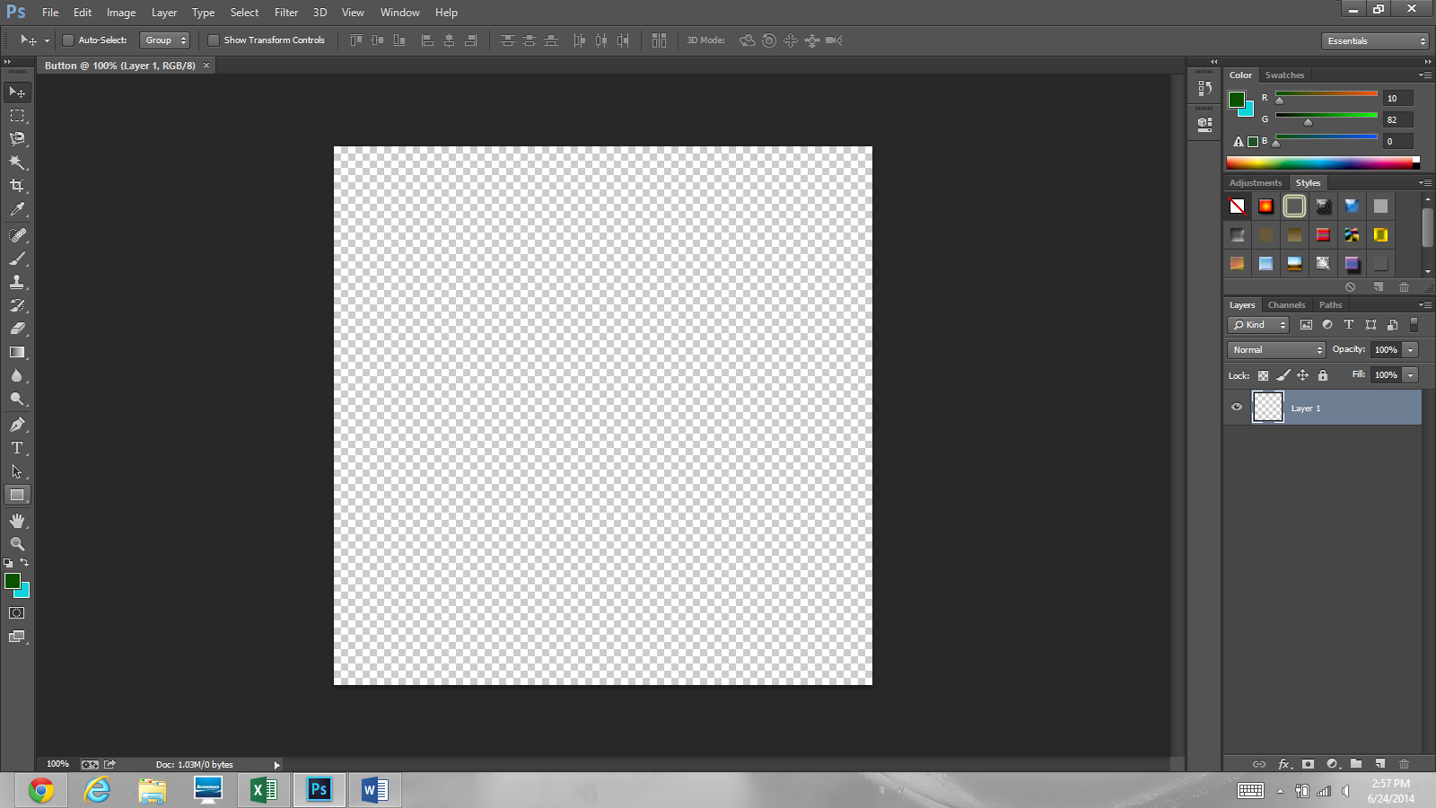

Click on the “Rectangle Tool” to begin making our button’s shape.

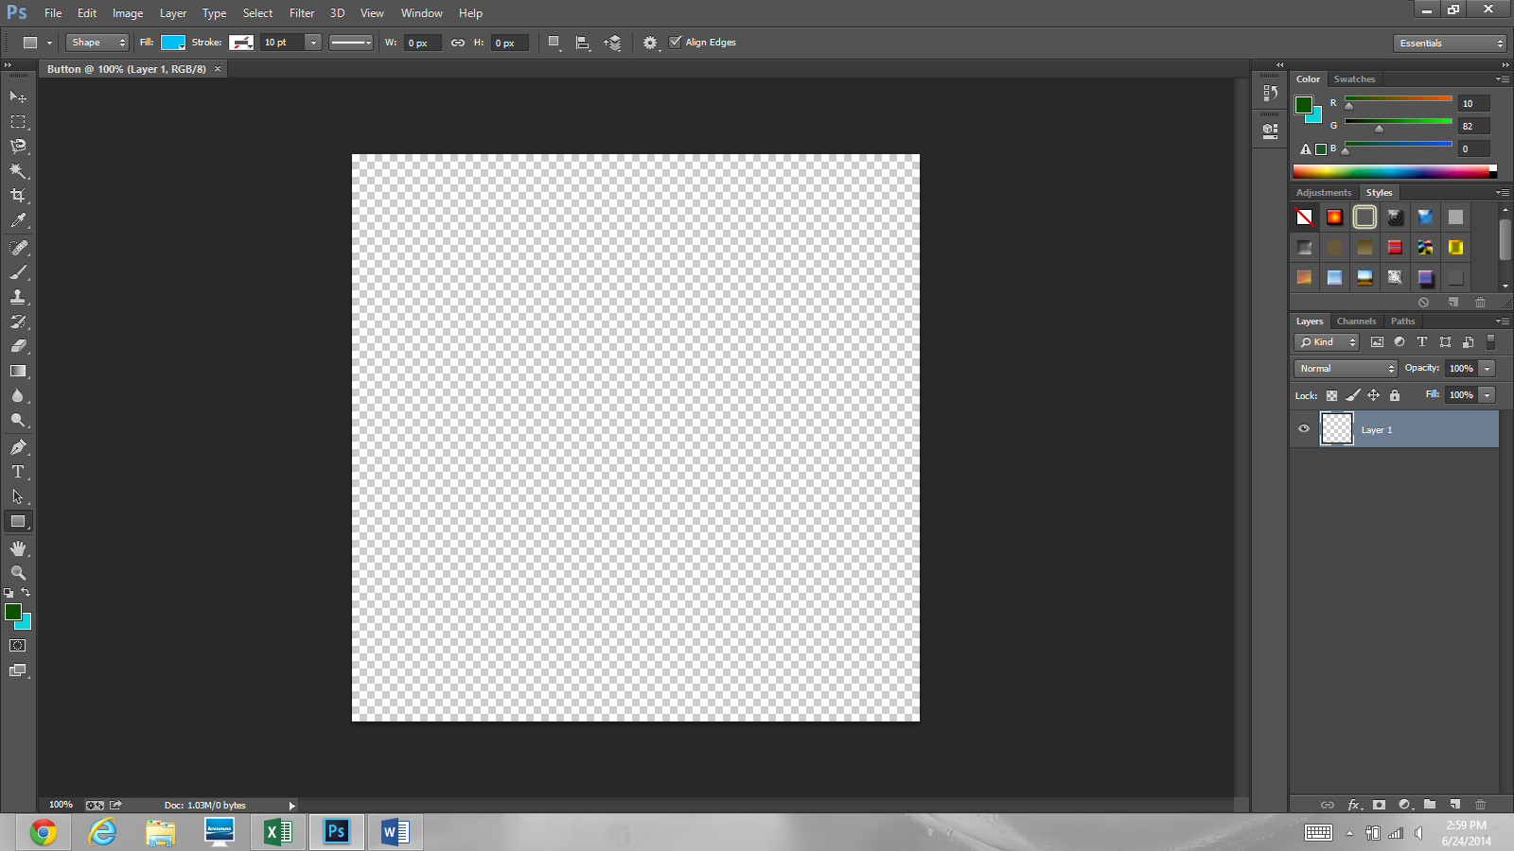

There are multiple settings that can be changed such as “Fill” and “Stroke.” Fill is the area inside of the rectangle and stroke is the outline of the rectangle. I am going to leave these settings alone. You can try changing some of these settings later to see what they all do.

Now click somewhere in about the middle of the background to start your rectangle. This will set the middle point of the rectangle to this position. It can be changed later if you please.

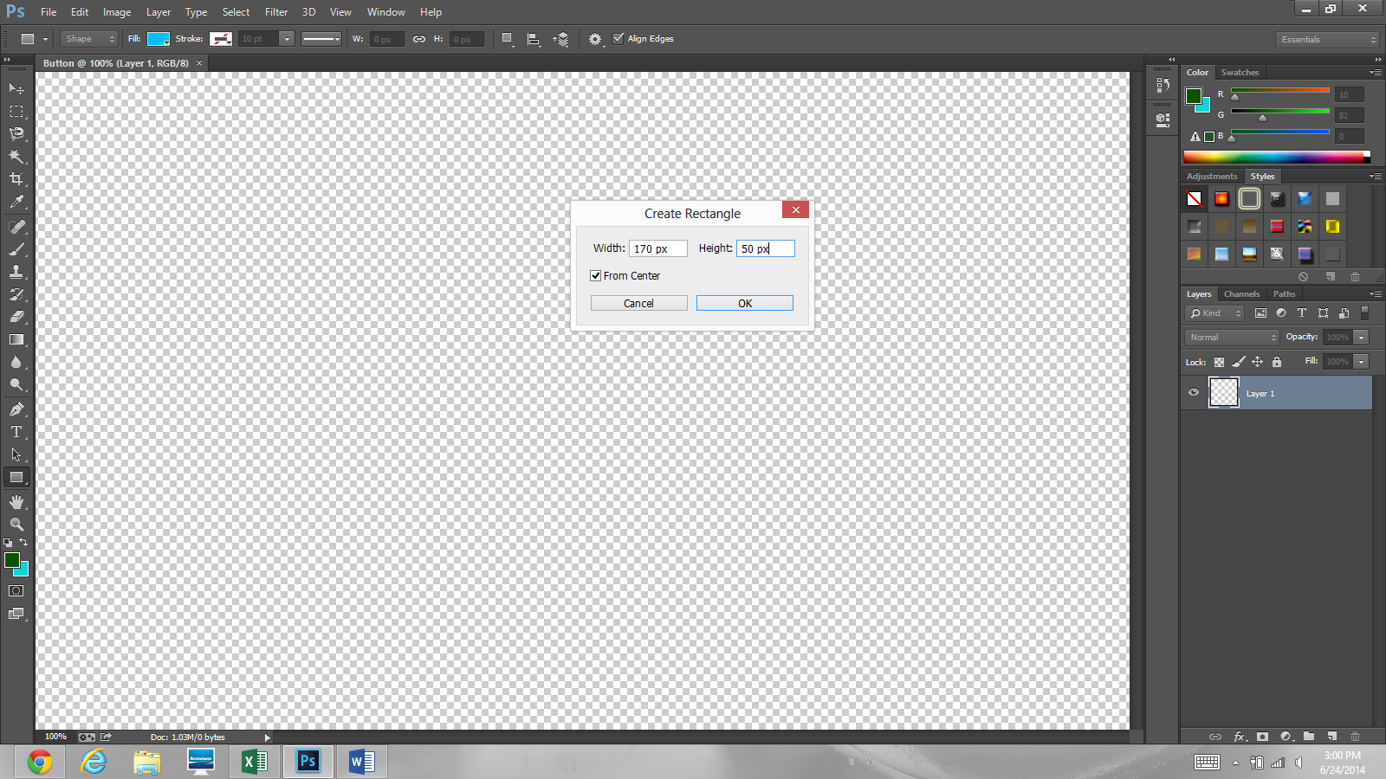

This screen will appear next. It is prompting you to choose the width and height of the rectangle. I will set it to a width of 170 pixels and a height of 50 pixels. “From Center” will make Photoshop recognize the place we click to be the center of the rectangle. Make sure this box is checked. Next, click “OK.”

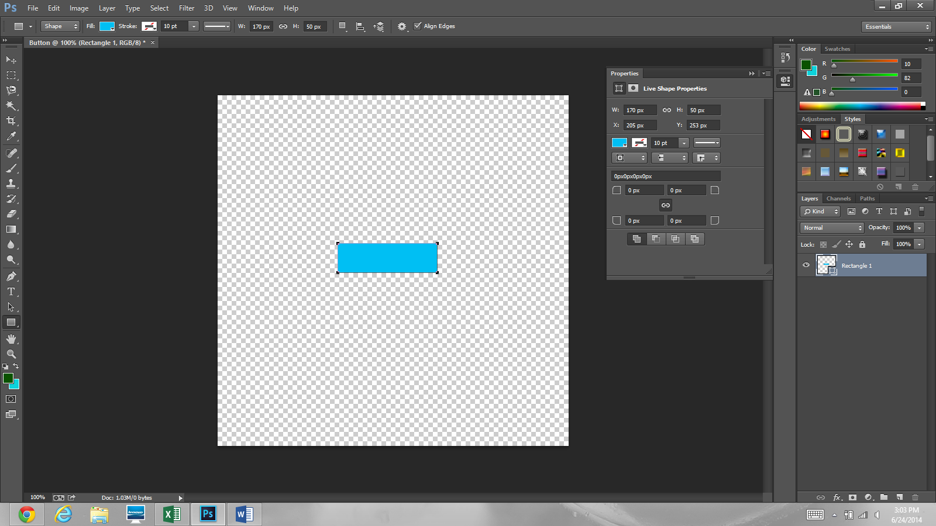

Now we have the basic shape of the button. It looks a little plain now so we will continue to edit it to make it look more aesthetically pleasing.

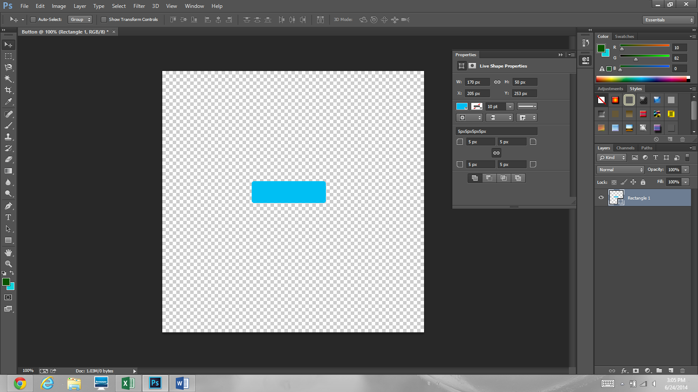

The first things I will edit are the corners of the rectangle. The sharp corners are not appealing. So, I will set the fillets to 5 pixels. This means that the radius of the curve on the corners of the rectangles is now 5 pixels. Then, press the double arrow across from the properties tab to minimize the properties box.

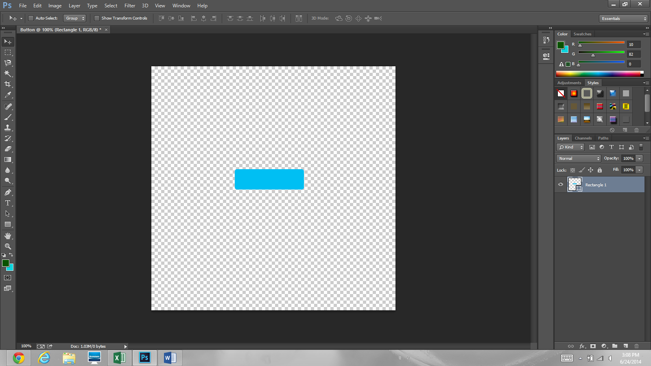

Now, double click “Rectangle 1” under the layers tab to pull up the “Layer Style” dialogue box. You can edit the name of the layer by double clicking the name of the layer.

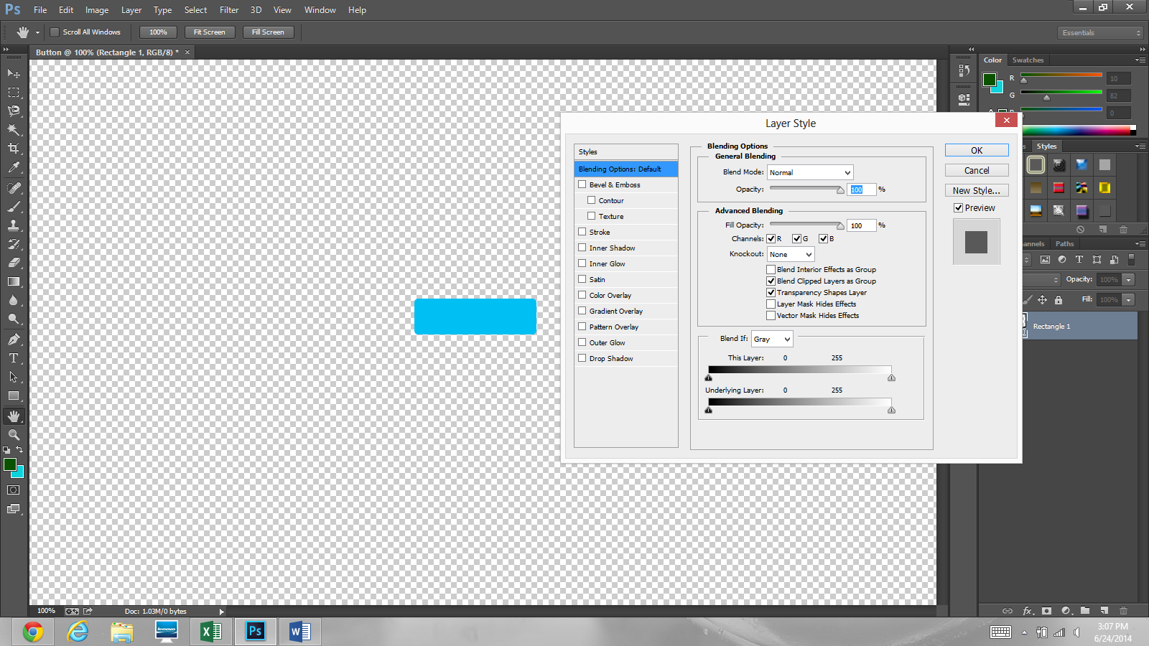

The layer style box includes many different options for editing the properties of the layer selected. In this tutorial, I will discuss the “Gradient Overlay” and “Stroke” features. I am going to zoom in on the following screen captures so you can more clearly see what I am doing in the programme.

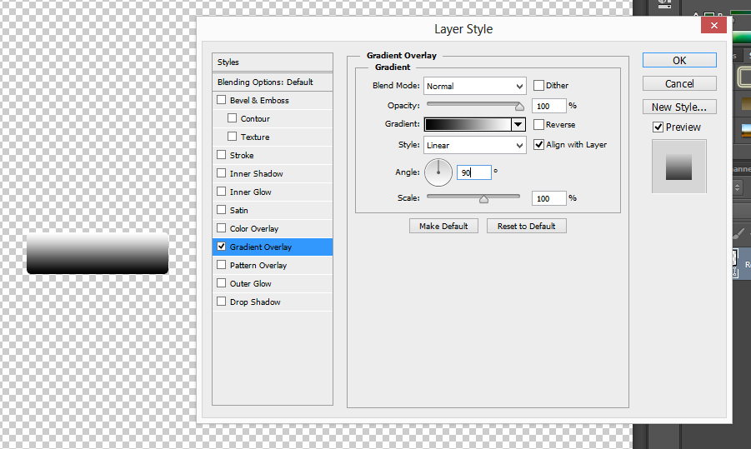

Click on “Gradient Overlay” from the list of styles on the right hand side of the “Layer Style” dialogue box. The gradient overlay will set the colour of the button by colouring over the original color of the button. Click on the box next to the word “Gradient” to change the colour of the gradient overlay.

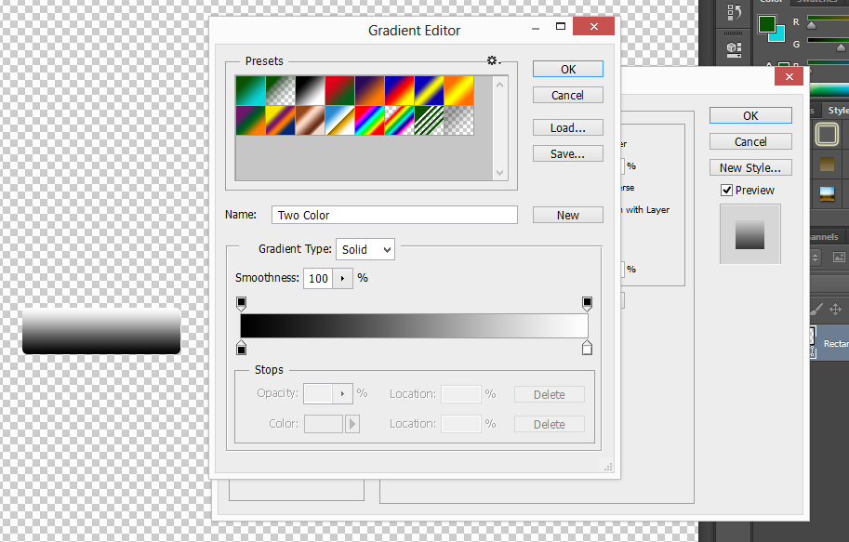

Click the first stop.

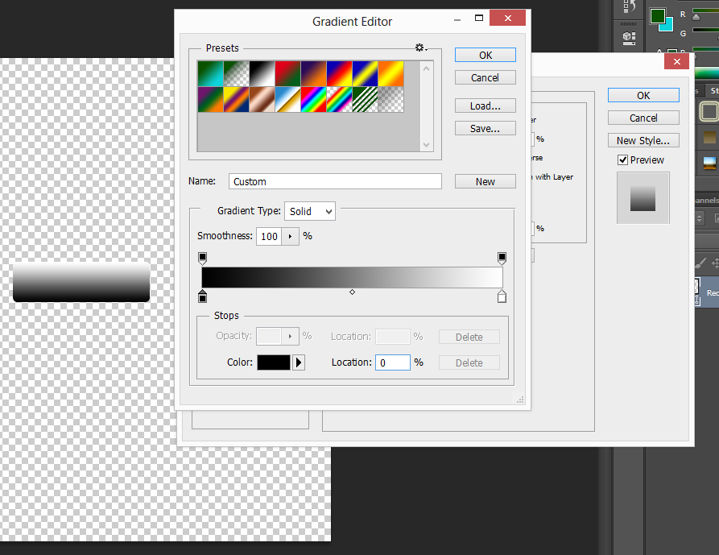

Now that the first stop is clicked we can see that the colour and location have become available to edit. Click the box next to the word “Colour” to open the dialogue box that will allow us to set the colour for this first stop which will be our darkest colour in the gradient.

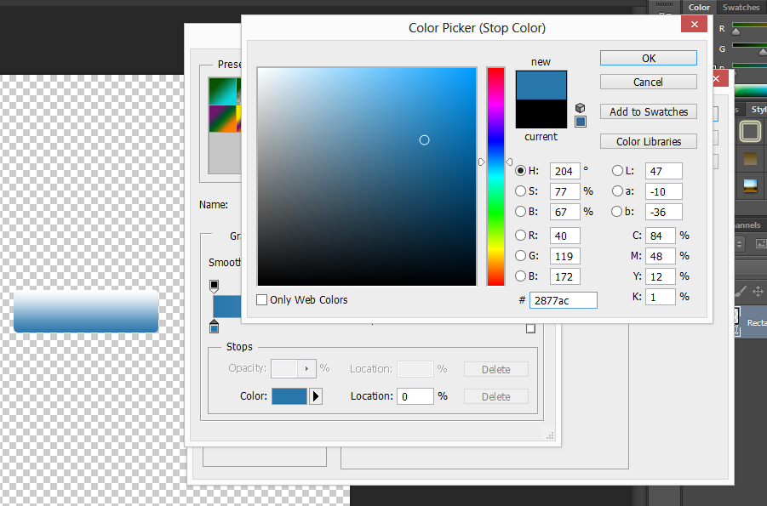

The “Color Picker” dialogue allows us to choose the stop colour. I found a colour I thought would look nice. You can easily add this colour by changing the colour number to “2877ac.” Click “OK” to set this colour and close the dialogue box.

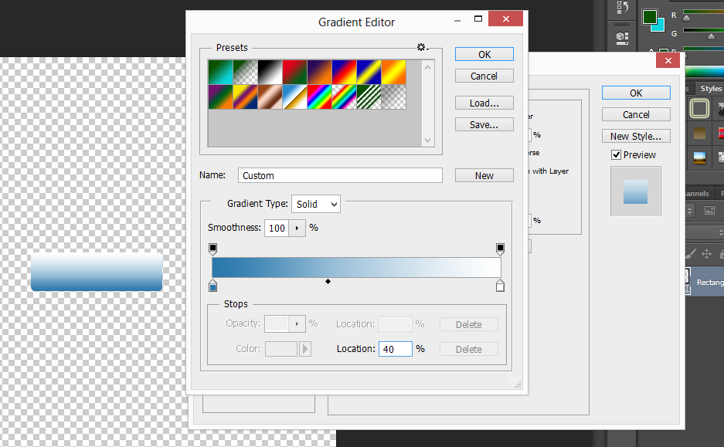

Now, click somewhere below the bar of color indicated by the red arrow.

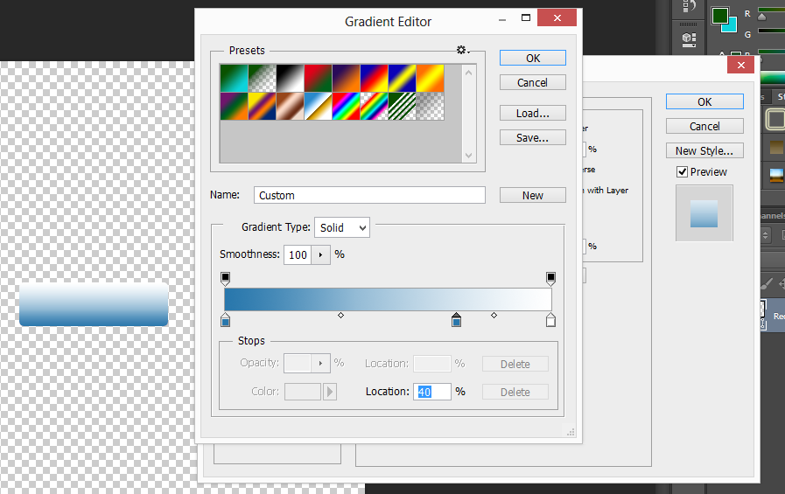

There is now a new stop colour and a new colour midpoint. The colour midpoints are indicated by the red arrows. The new stop colour is the icon in the red circle. Change the colour midpoints to be at the location “40%.” This makes the first midpoint 40% of the way between the first and second colour stop and the second midpoint 40% of the way between the second and third colour stop,

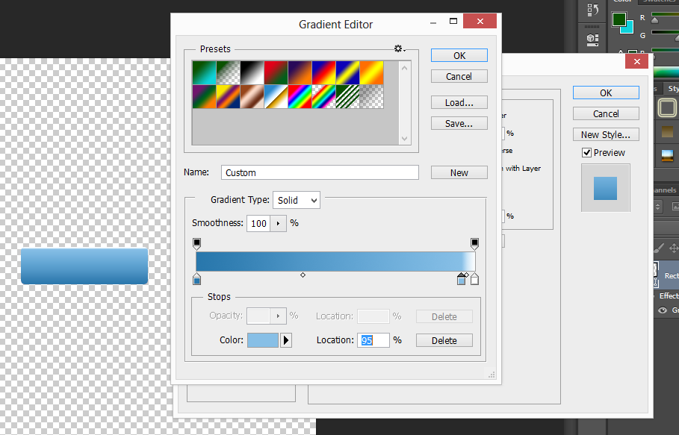

The second colour stop should be at the location 95% and indicate its colour to be #87bfe6. This is a lighter shade of the first colour stop.

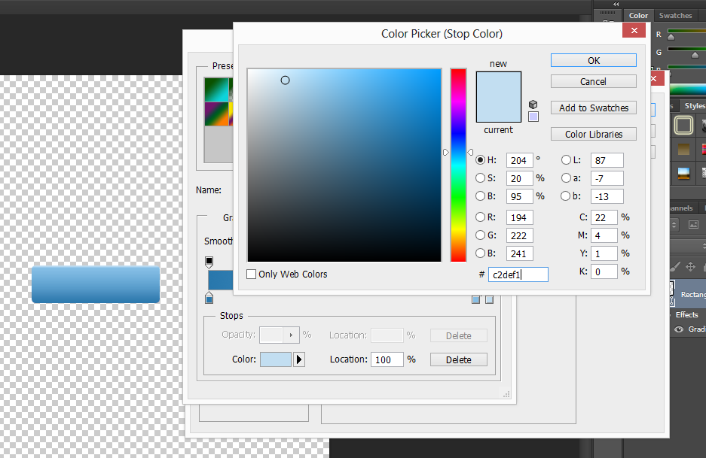

The third colour stop should be at the location 100%. Its colour is indicated by the colour code- #c2def1.

Now, we will focus on the stroke settings. Click “OK” to close the Colour Picker dialogue box and “OK” again to close the Gradient Overlay dialogue box.

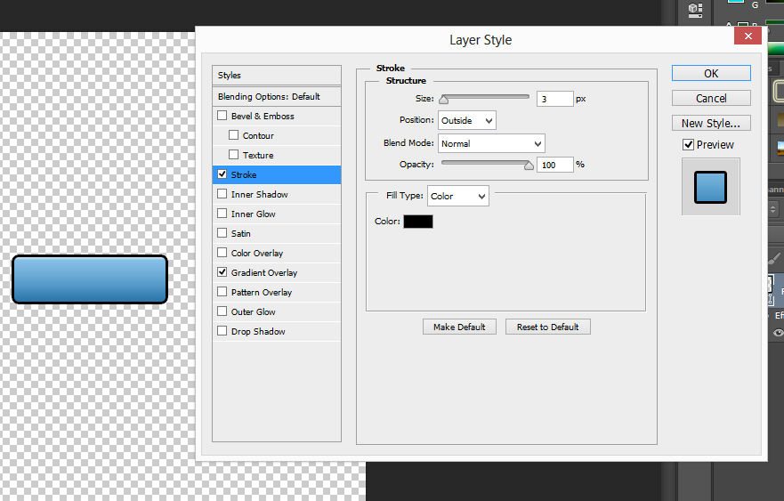

Click on the stroke button to open stroke options.

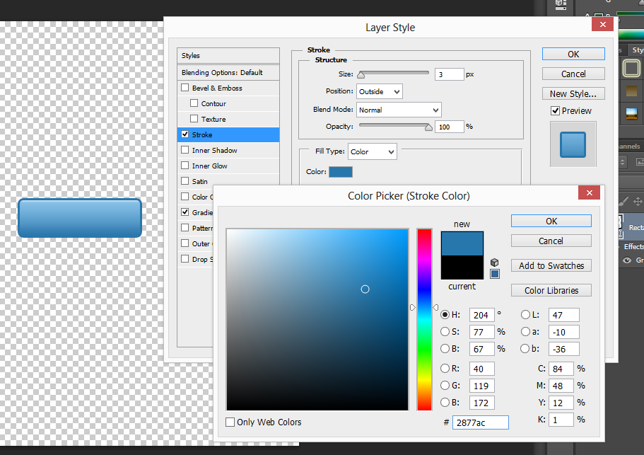

Use the darkest colour from the Gradient Overlay stop colours as the stroke colour. The code for this colour is #2877ac. Do this by clicking the box next to the word “Color” under “Fill Type” and enter the colour code into the Colour Picker dialogue box. Now, click “OK” to close the Colour Picker dialogue box.

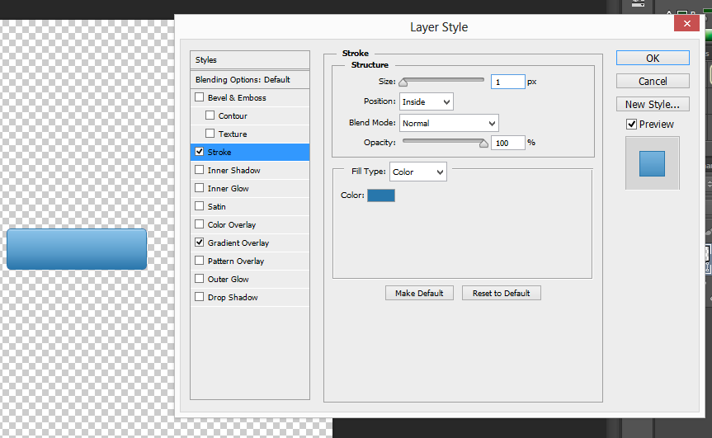

Now, work on the Structure of the stroke. Set the Size to 1 pixel and the Position to inside. This will make the outline of the button 1 pixel thick inside the button’s perimeter instead of outside.

Next, the text needs to be added. Click “OK” to exit the Layer Style dialogue box. I have zoomed in to see the button more clearly.

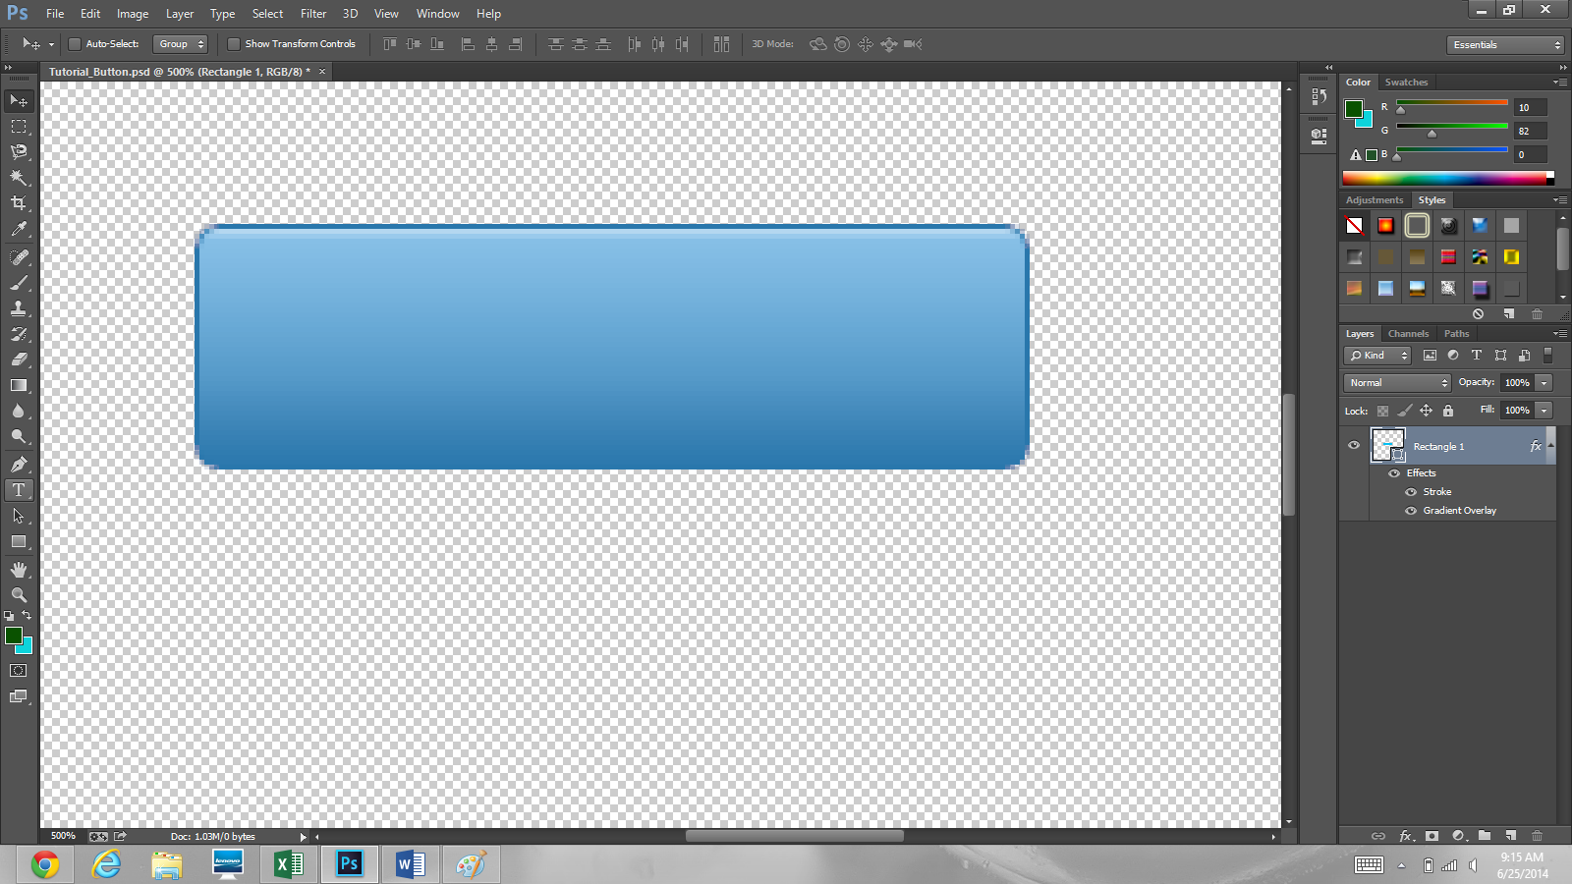

Click the Horizontal Type Tool to insert text.

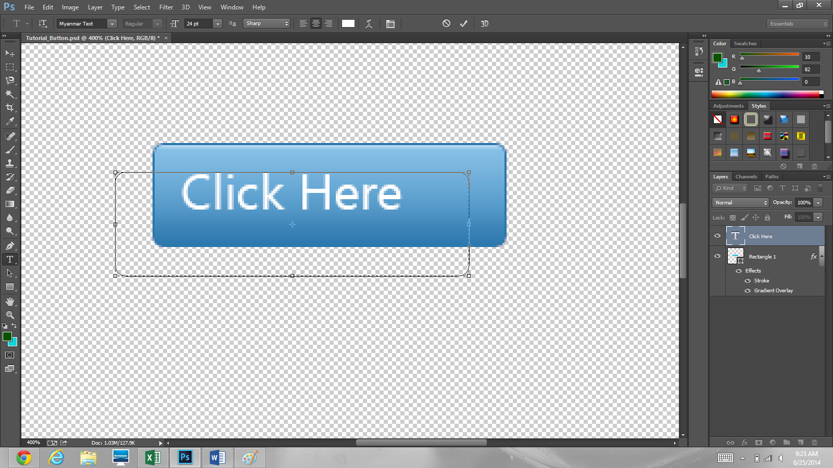I used Myanmar text at 24 pt font. Click on the colour box and change the colour in the colour picker dialogue box to #ffffff which is the colour code for white. You may need to move the text to make it in the correct position in the button. Do this by clicking the Move Tool which is indicated by the red arrow. Then, click on the text and drag to move it around.

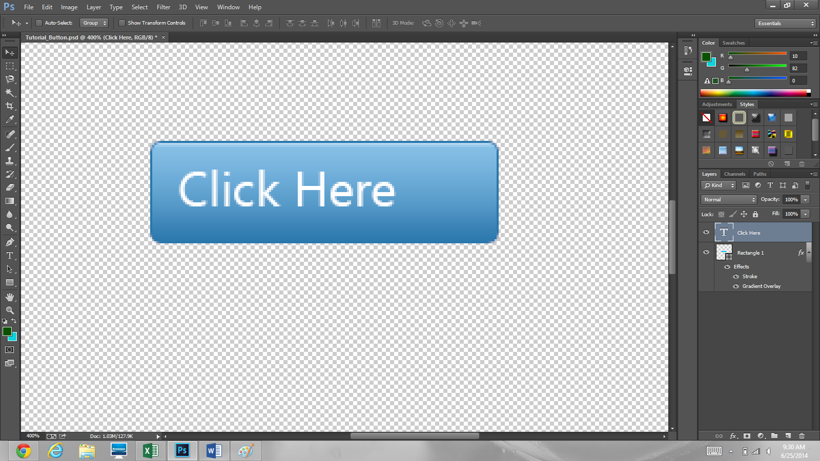

Double click the text layer named “Click Here” to open the Layer Style dialogue box. Then, click the “Drop Shadow” option.

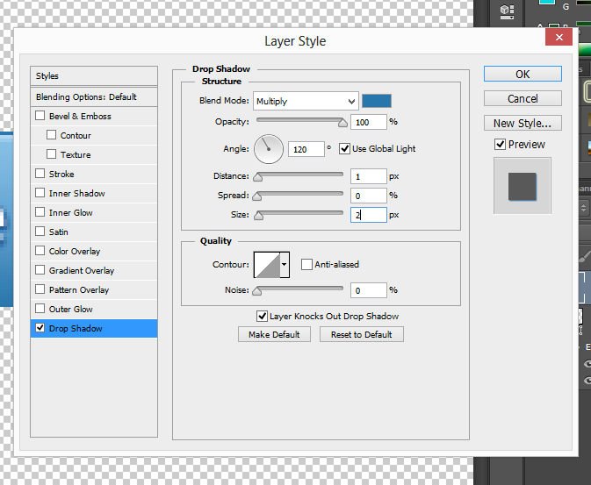

Change the Blend colour to the darkest colour from the gradient (#2877ac). Set the opacity to 100%, the distance to 1 pixel and size to 2 pixels. Next, we are going to add an arrow to the button.

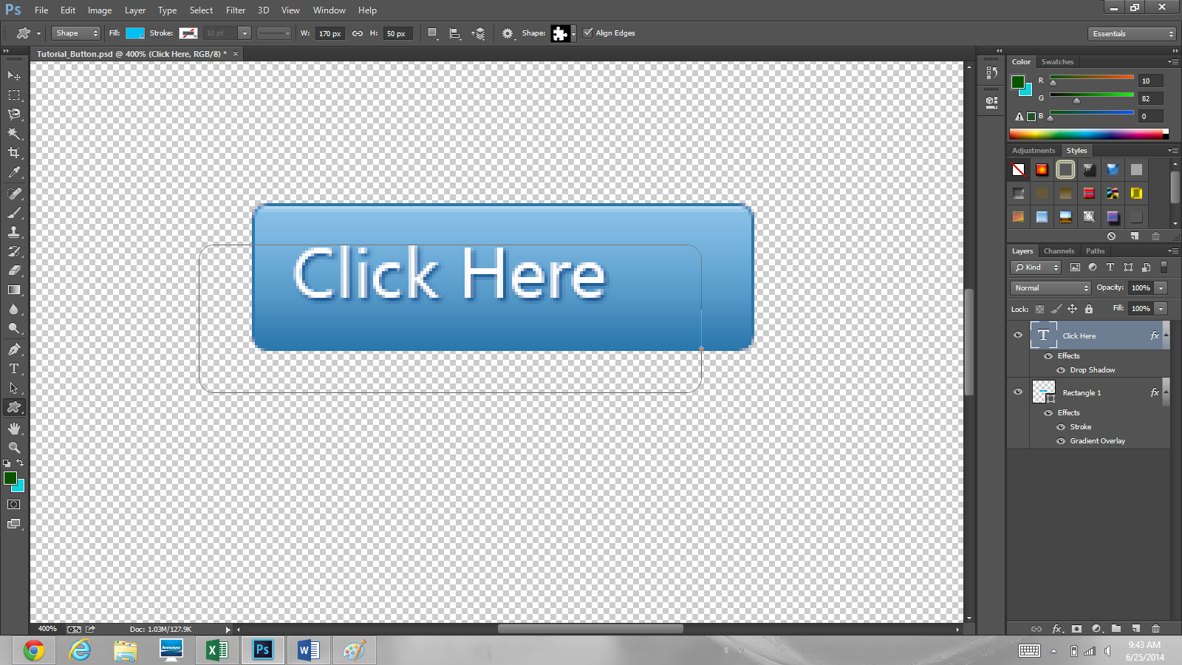

To access the “Custom Shape Tool,” click ‘shift+U’ until the icon indicated by the red arrow is the one in the screenshot above. It is in the same location as “Rectangle Tool.”

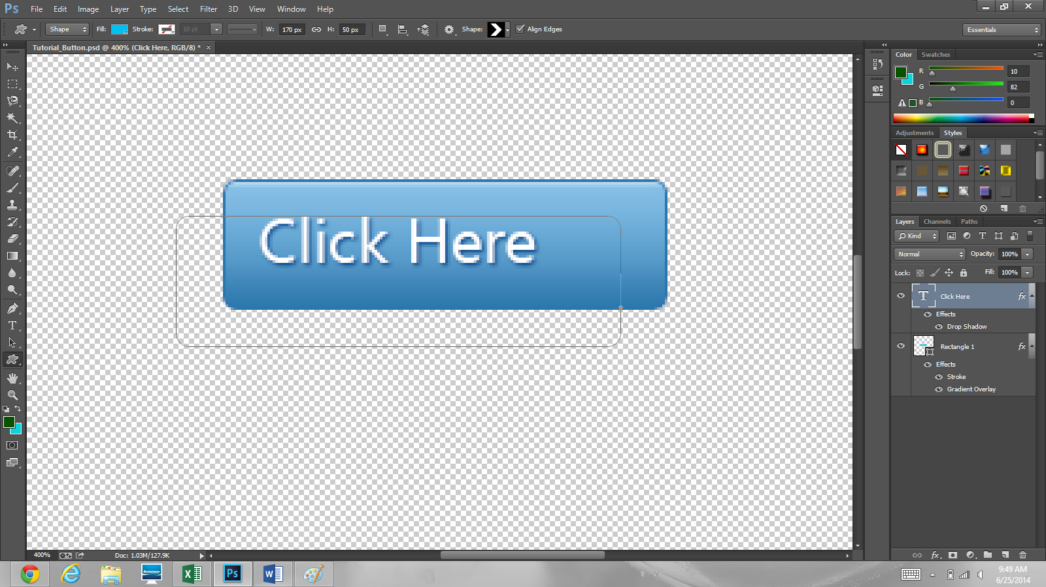

The arrow I selected is called Arrow 2. Simply click on the area located by the red arrow. Change the fill to white (#ffffff).

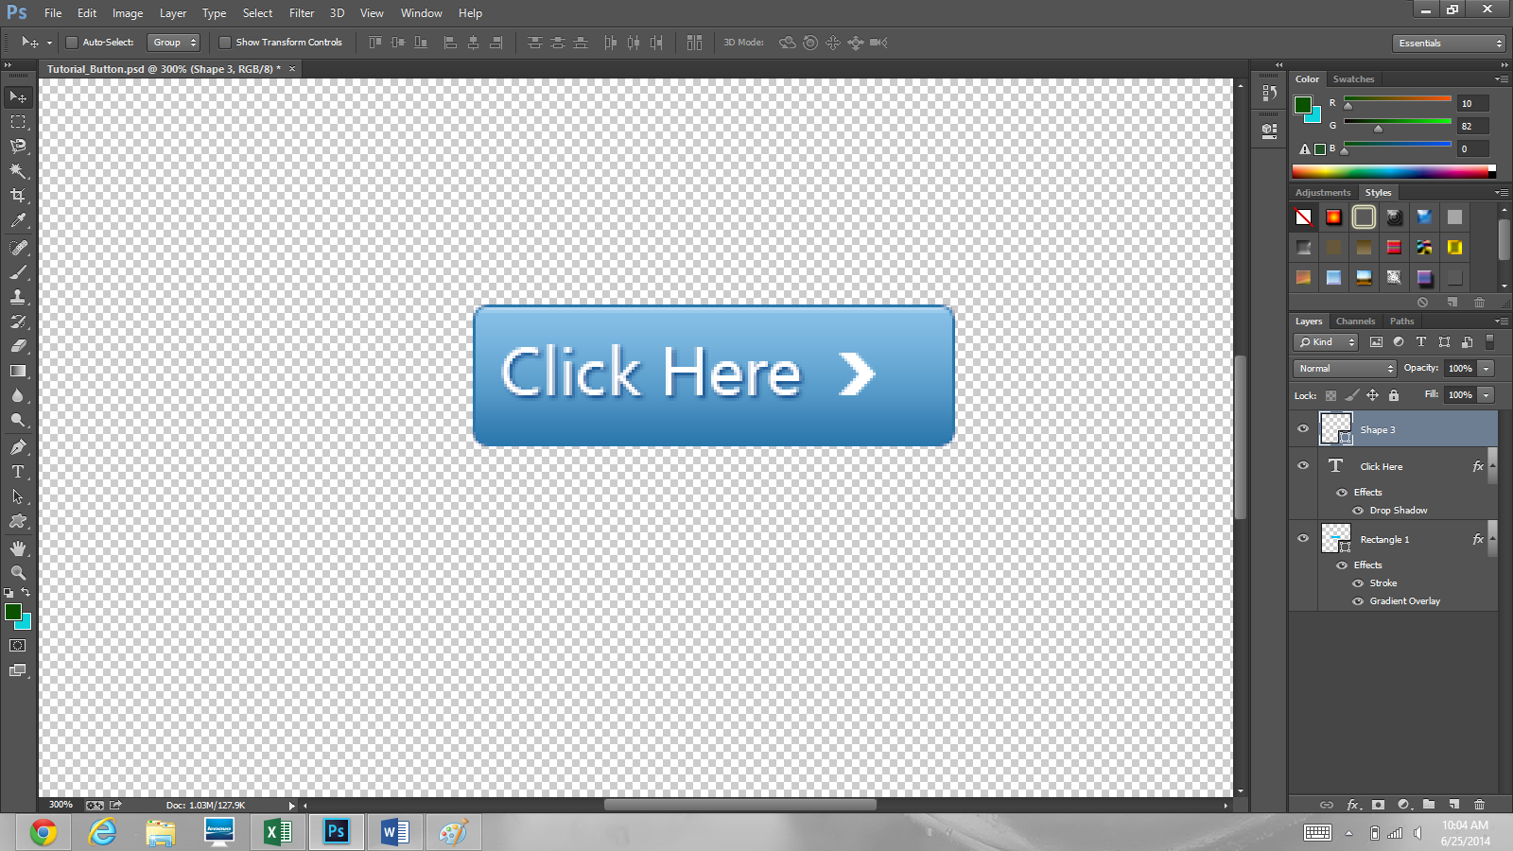

Click next to the text on the button and set the width as 0.181 inches and the height as 0.208 inches. This is the same height of the lowercase letters.



Now, the button is done. You can change the color and text of the button to suit your needs. This is the end of the tutorial. Thank you!